* **What is software? What is software engineering?**
* Software is a set of instructions, data, or programs used to operate a computer and execute specific tasks. In simpler terms, software tells a computer how to function. It’s a generic term used to refer to applications, scripts, and programs that run on devices such as PCs, mobile phones, tablets, and other smart devices. Software contrasts with hardware, which is the physical aspects of a computer that perform the work.
* Software engineering is a systematic engineering approach to software development. A software engineer is a person who applies the principles of software engineering to design, develop, maintain, test, and evaluate computer software.

* **Explain types of software.**
* **Application software =** The most common type of software, application software is a computer software package that performs a specific function for a user, or in some cases, for another application. An application can be self-contained, or it can be a group of programs that run the application for the user. Examples of [modern applications](https://www.techtarget.com/searchcio/feature/The-rise-of-modern-applications-Why-you-need-them) include office suites, graphics software, databases and database management programs, web browsers, word processors, software development tools, image editors and communication platforms.
* **System software =** These software programs are designed to run a computer's application programs and hardware. System software coordinates the activities and functions of the hardware and software. In addition, it controls the operations of the computer hardware and provides an environment or platform for all the other types of software to work in. The OS is the best example of system software; it manages all the other computer programs. Other examples of system software include the [firmware](https://www.techtarget.com/whatis/definition/firmware), computer language translators and system [utilities](https://www.techtarget.com/whatis/definition/utility).
* **Driver software =**Also known as device drivers, this software is often considered a type of system software. Device drivers control the devices and peripherals connected to a computer, enabling them to perform their specific tasks. Every device that is connected to a computer needs at least one device driver to function. Examples include software that comes with any nonstandard hardware, including special game controllers, as well as the software that enables standard hardware, such as USB storage devices, keyboards, headphones and printers.
* **Middleware =**The term *middleware* describes software that mediates between application and system software or between two different kinds of application software. For example, middleware enables Microsoft Windows to talk to Excel and Word. It is also used to send a remote work request from an application in a computer that has one kind of OS, to an application in a computer with a different OS. It also enables newer applications to work with legacy ones.
* **Programming software =** Computer programmers use programming software to write code. Programming software and programming tools enable developers to develop, write, test and [debug](https://www.techtarget.com/searchsoftwarequality/definition/debugging) other software programs. Examples of programming software include assemblers, compilers, debuggers and interpreters.
* **What is SDLC? Explain each phase of SDLC?**
* SDLC or the Software Development Life Cycle is a process that produces software with the highest quality and lowest cost in the shortest time possible. SDLC provides a well-structured flow of phases that help an organization to quickly produce high-quality software which is well-tested and ready for production use.
* **Planning Stage** = Before we even begin with the planning stage, the best tip we can give you is to take time and acquire proper [understanding of app development life cycle.](https://clouddefense.ai/blog/understanding-app-development-life-cycle) The planning stage (also called the feasibility stage) is exactly what it sounds like, the phase in which developers will plan for the upcoming project
* **Analysis Stage =** The analysis stage includes gathering all the specific details required for a new system as well as determining the first ideas for prototypes.

Developers may:

1.) Define any prototype system requirements

2.) Evaluate alternatives to existing prototypes

3.) Perform research and analysis to determine the needs of end-users.

* **Design Stage** = The design stage is a necessary precursor to the main developer stage. Developers will first outline the details for the overall application, alongside specific aspects, such as its:

1. User interfaces
2. System interfaces
3. Network and network requirements
4. Databases

### Development Stage = The development stage is the part where developers actually write code and build the application according to the earlier design documents and outlined specifications.

* **Testing Stage** = Building software is not the end. Now it must be tested to make sure that there aren’t any bugs and that the end-user experience will not negatively be affected at any point.

During the testing stage, developers will go over their software with a fine-tooth comb, noting any bugs or defects that need to be tracked, fixed, and later retested.

### Implementation and Integration Stage = After testing, the overall design for the software will come together. Different modules or designs will be integrated into the primary source code through developer efforts, usually by leveraging training environments to detect further errors or defects.

The information system will be integrated into its environment and eventually installed. After passing this stage, the software is theoretically ready for market and may be provided to any end-users.

* **Maintenance Stage** = The SDLC doesn’t end when software reaches the market. Developers must now move into a maintenance mode and begin practicing any activities required to handle issues reported by end-users.
* **What is DFD? Create a DFD diagram on Flipkart.**
* A data-flow diagram is a way of representing a flow of data through a process or a system (usually an information system). The DFD also provides information about the outputs and inputs of each entity and the process itself. A data-flow diagram has no control flow — there are no decision rules and no loops. Specific operations based on the data can be represented by a flowchart.

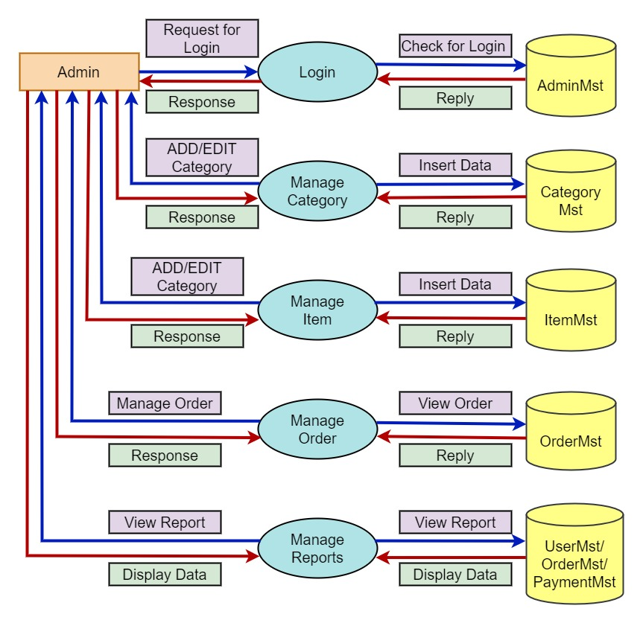

* **What is Flow chart? Create a flowchart to make addition of two numbers.**
* A flowchart is a type of [diagram](https://en.wikipedia.org/wiki/Diagram) that represents a [workflow](https://en.wikipedia.org/wiki/Workflow) or [process](https://en.wikipedia.org/wiki/Process). A flowchart can also be defined as a diagrammatic representation of an [algorithm](https://en.wikipedia.org/wiki/Algorithm), a step-by-step approach to solving a task.

The flowchart shows the steps as boxes of various kinds, and their order by connecting the boxes with arrows. This diagrammatic representation illustrates a solution model to a given [problem](https://en.wikipedia.org/wiki/Problem_solving). Flowcharts are used in analyzing, designing, documenting or managing a process or program in various fields.

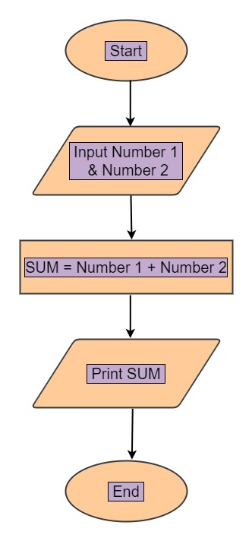

* **What is Use case Diagram? Create a use-case on bill payment on paytm.**
* A use case diagram is a graphical depiction of a user's possible interactions with a system. A use case diagram shows various use cases and different types of users the system has and will often be accompanied by other types of diagrams as well. The use cases are represented by either circles or ellipses. The actors are often shown as stick figures.

